Exploratory Data Analysis with Sales Data

Student Name: Rajanya Dhar
Roll No: 243034-11-0047
Registration No: 034-1211-0325-24
Batch: 2024-2028
Course: B.Sc. in Economics, 2nd Year (4th Semester)
Institute: Shri Shikshayatan College
Project Guide / Mentor Name: Prof. Chandan Biswas

Period of Internship: 18th May 2026 – 14th June 2026
Report submitted to:
IDEAS – Institute of Data Engineering, Analytics and Science Foundation, ISI Kolkata

ABSTRACT
This project presents a comprehensive analysis of a retail sales dataset containing weekly sales records from multiple stores and departments over a three-year period. The objective of the study is to explore sales patterns, understand the impact of holidays on revenue generation, and identify key factors influencing sales performance. The dataset consists of 156,000 observations with information on store IDs, department IDs, weekly sales, dates, and holiday indicators.
Exploratory Data Analysis (EDA) was performed to examine the distribution of sales, detect trends, and identify seasonal patterns. The analysis revealed significant variations in sales across stores and departments, indicating differences in customer demand and operational performance. Time-series analysis highlighted recurring seasonal fluctuations, with noticeable increases in sales during holiday periods. The study also examined the relationship between holiday weeks and sales performance, showing that holidays have a positive impact on retail revenue.
Furthermore, statistical analysis was conducted to summarize sales behaviour and identify outliers representing exceptionally high sales periods. The findings suggest that a small number of stores and departments contribute substantially to overall revenue, emphasizing the importance of targeted business strategies. Based on the insights obtained, recommendations were proposed regarding inventory management, promotional planning, and sales forecasting.
The results demonstrate the value of data-driven decision-making in retail operations and provide a foundation for future predictive modelling and forecasting techniques. This analysis can assist retailers in improving operational efficiency, optimizing resource allocation, and enhancing overall business performance.

INTRODUCTION
In today's highly competitive retail industry, data-driven decision-making plays a crucial role in improving business performance and customer satisfaction. Retail organizations generate large volumes of sales data through daily transactions, which can be analysed to uncover valuable insights regarding customer behaviour, sales trends, and operational efficiency. Effective analysis of such data enables businesses to optimize inventory management, develop targeted marketing strategies, and improve overall profitability.
This project focuses on the analysis of a retail sales dataset containing weekly sales records from multiple stores and departments over a three-year period. The dataset includes information such as store identification, department identification, weekly sales figures, dates, and holiday indicators. By examining these variables, it is possible to understand how sales vary across different stores and departments, identify seasonal patterns, and evaluate the impact of holidays on revenue generation.
The primary objective of this study is to perform Exploratory Data Analysis (EDA) to gain meaningful insights from the dataset and identify factors influencing sales performance. Various statistical and visualization techniques are employed to summarize the data, detect trends, analyse seasonal fluctuations, and identify unusual sales patterns. Special attention is given to understanding how holiday periods affect consumer purchasing behaviour and overall sales performance.
The findings of this analysis can assist retailers in making informed business decisions related to inventory planning, resource allocation, promotional campaigns, and demand forecasting. Furthermore, the study provides a foundation for future predictive modelling and advanced analytics, enabling organizations to enhance operational efficiency and achieve sustainable growth in an increasingly data-driven business environment.
Training Topics Covered During the First Two Weeks of Internship:
During the initial two weeks of the Summer Internship Program 2026 organized by the Institute of Data Engineering, Analytics and Science Foundation (IDEAS), we, the We underwent structured training sessions designed to build a strong foundation in Python programming, Artificial Intelligence, Machine Learning, and essential professional competencies. The details of the sessions conducted are outlined below.

Week I: Python Programming Fundamentals
• Internship Program Orientation and Introduction
The internship commenced with an orientation session that provided an overview of the program objectives, expected learning outcomes, project requirements, assessment methods, and the growing significance of Data Science and Artificial Intelligence in addressing real-world challenges.
• Python Fundamentals – I (Data Types, Variables, Lists, and Loops)
This session introduced the core concepts of Python programming, including data types, variables, operators, lists, and control flow statements. We learned how to use iterative structures such as for and while loops to perform repetitive computational tasks.
• Python Fundamentals – II (Data Structures)
The training focused on key Python data structures, namely tuples, dictionaries, and sets. Emphasis was placed on understanding their characteristics and practical applications in organizing and managing data efficiently.
• Python Fundamentals – III (Functions, Classes, and Object-Oriented Programming)
This module covered Python functions, modules, classes, and objects. We were introduced to fundamental object-oriented programming concepts such as encapsulation, inheritance, and polymorphism, enabling the development of modular, reusable, and maintainable code.
• Python Fundamentals – IV (NumPy and Pandas)
An introduction to the NumPy and Pandas libraries was provided. NumPy was utilized for numerical computations and array manipulations, while Pandas was explored for data cleaning, transformation, organization, and analysis of structured datasets.
Week II: Artificial Intelligence and Machine Learning
• Introduction to Machine Learning
This session presented an overview of Artificial Intelligence and Machine Learning, highlighting their importance, real-world applications, and various learning approaches, including supervised, unsupervised, and reinforcement learning.

• Machine Learning – I
We were introduced to the machine learning development process, with a focus on data preprocessing techniques. Topics included handling missing data, encoding categorical features, feature scaling, and dividing datasets into training and testing sets for model building.
• Machine Learning – II
This session explored machine learning classification methods and model evaluation techniques. It covered predictive modelling concepts, performance measurement using evaluation metrics, and common challenges such as overfitting and underfitting.
• Fundamentals of Large Language Models (LLMs)
An overview of Generative Artificial Intelligence and Large Language Models was provided, focusing on their core principles, capabilities, applications, limitations, and their increasing influence across diverse sectors.
• Communication Skills Development
The final session emphasized the significance of effective communication in professional settings. Key topics included verbal and written communication, presentation skills, teamwork, interpersonal effectiveness, and methods for presenting technical information in a clear, concise, and confident manner.

PROJECT OBJECTIVE
• To develop practical proficiency in Python programming by applying Python libraries and tools for data cleaning, manipulation, analysis, and visualization of real-world retail sales data.
• To understand and apply fundamental concepts of Artificial Intelligence and Machine Learning through the analysis of large datasets, enabling data-driven decision-making and predictive thinking.
• To analyse weekly sales performance across different stores and departments in order to identify sales patterns, high-performing business units, and areas requiring improvement.
• To investigate the impact of holidays and seasonal variations on sales trends using exploratory data analysis and visualization techniques to uncover meaningful business insights.
• To build analytical and problem-solving skills by extracting actionable insights from data, thereby supporting business decisions related to inventory management, marketing strategies, demand forecasting, and operational efficiency.

METHODOLOGY
Research Methodology
The methodology adopted in this project follows a systematic data analytics approach to examine retail sales data and derive meaningful business insights. The project was conducted as part of the Summer Internship Program 2026 organized by the Institute of Data Engineering, Analytics and Science Foundation (IDEAS). Throughout the internship, practical exposure to Python Programming, Artificial Intelligence (AI), and Machine Learning (ML) was provided through hands-on assignments and data-driven problem-solving activities.
The project involved the use of a retail sales dataset containing weekly sales records from multiple stores and departments. Using Python-based analytical techniques, the dataset was processed, analyzed, and visualized to identify trends, patterns, and business opportunities. Additionally, introductory machine learning concepts were explored using the MNIST handwritten digit dataset.
3.2 Tools and Technologies Used
The project was implemented using the following tools and technologies:
Tool/Library | Purpose
Python | Programming and analysis
Google Collab | Development environment
Pandas | Data manipulation and preprocessing
NumPy | Numerical computations
Matplotlib | Data visualization
Seaborn | Statistical visualization
Scikit-Learn | Machine learning implementation

Skills Acquired
- Python Programming Fundamentals
- Data Handling and Manipulation
- Exploratory Data Analysis (EDA)
- Data Visualization
- Statistical Analysis
- Introduction to Artificial Intelligence
- Machine Learning Fundamentals
- Model Evaluation Techniques

Dataset Description
The dataset used for analysis contains weekly sales records collected from various retail stores and departments.
Dataset Features: -
Attribute | Description
store_id | Unique store identifier
department | Department identifier
date | Weekly sales date
weekly sales | Weekly sales amount
is holiday | Holiday indicator

Dataset Characteristics
- Total Records: 156,000
- Number of Stores: 50
- Number of Departments: 20
- Time Span: Multiple Years
- Data Type: Structured Retail Sales Data
The dataset provides valuable information for understanding customer purchasing behavior, store performance, departmental contribution, and seasonal sales variations.
Overall Project Workflow
The project followed a structured workflow beginning with data acquisition and ending with insight generation.
Workflow: -
Dataset Collection
│
▼
Data Loading using Python
│
▼
Data Cleaning & Preparation
│
▼
Exploratory Data Analysis
│
▼
Visualization & Trend Analysis
│
▼
Business Insights
│
▼
AI & ML Learning Activities
│
▼
Result Interpretation

3.5 Data Loading and Preprocessing
The first phase of the project involved importing the dataset into the Python environment. The CSV file was loaded using the Pandas library, allowing efficient handling of large datasets.
Activities Performed
- Importing required Python libraries.
- Reading the dataset using Pandas.
- Inspecting data structure and dimensions.
- Examining column names and data types.
- Verifying numerical values.
- Converting date columns into datetime format.
- Creating month-based features for trend analysis.
- Preparing data for aggregation and visualization.
Python Functions Used
- pd.read_csv()
- head()
- info()
- describe()
- to_datetime()

Importance
Proper preprocessing ensures data quality and improves the reliability of subsequent analyses. Clean and structured data forms the foundation for accurate business intelligence and machine learning applications.

3.6 Store-wise Revenue Analysis
The first analytical task focused on identifying stores generating the highest overall revenue.
Objective
- Determine top-performing stores.
- Compare store-wise revenue generation.
- Understand contribution of individual stores.
Methodology
- Group data by Store ID.
- Calculate total sales for each store.
- Sort stores according to revenue.
- Extract top-performing stores.
Python Functions Used
- groupby()
- sum()
- sort_values()
- head()
Output Generated
- Ranked store revenue table.
- Revenue comparison visualization.
- Identification of top-performing stores.
Business Significance
Store-level revenue analysis assists management in identifying successful business locations and developing strategies for performance improvement in lower-performing stores.

3.7 Department Performance Consistency Analysis
This analysis evaluated how consistently departments generated sales over time.
Objective
- Measure sales stability.
- Identify predictable departments.
- Detect highly volatile departments.
Statistical Measures Used
Standard Deviation
Measures the spread of sales values around the average.
Lower Standard Deviation:
- More consistent sales.
- Greater predictability.
Higher Standard Deviation:
- Greater fluctuations.
- Less stable demand.
Coefficient of Variation (CV)
Formula:
CV = Standard Deviation ÷ Mean Sales
Used to compare variability across departments regardless of sales volume.

Python Functions Used
- mean()
- std()
- groupby()
Output Generated
- Department ranking.
- Stability comparison chart.
- Variability assessment.
Business Significance
Understanding departmental consistency helps improve inventory planning and demand forecasting.

3.8 Holiday Impact Analysis
The project examined how holiday periods influence retail sales performance.
Objective
- Compare holiday and non-holiday sales.
- Measure the effect of festive periods.
- Identify departments benefiting from holidays.
Methodology
- Separate holiday and non-holiday records.
- Compute average sales for each category.
- Compare performance.
- Calculate percentage differences.

Flowchart 3.2: Holiday Impact Analysis
Sales Dataset
│
▼
Separate Holiday Records
│
▼
Calculate Average Sales

│
▼
Compare with Non-Holiday Sales
│
▼
Measure Impact
Python Functions Used
- groupby()
- mean()
- loc[]
Output Generated
- Holiday sales statistics.
- Comparative analysis.
- Holiday impact visualization.
Business Significance
Retailers can utilize these insights to optimize inventory, staffing, and promotional campaigns during festive periods.

3.9 Seasonal Trend Detection
Seasonal analysis was conducted to identify recurring sales patterns throughout the year.
Objective
- Detect seasonal fluctuations.
- Identify peak sales months.
- Support demand forecasting.
Methodology
- Convert date column to datetime format.
- Extract month information.
- Group data by month.
- Calculate average monthly sales.
- Visualize sales trend.
Python Functions Used
- to_datetime()
- dt.month
- groupby()
- mean()
Output Generated
- Monthly sales trend chart.
- Seasonal performance insights.
- Identification of peak demand periods.
Business Significance
Seasonal trend analysis supports inventory planning, promotional scheduling, and strategic resource allocation.

3.10 Store-Department Contribution Analysis
The combined contribution of stores and departments was evaluated to identify key revenue drivers.
Objective
- Identify high-performing store-department combinations.
- Measure revenue contribution.
- Support strategic business decisions.
Methodology
- Group records by Store and Department.
- Calculate cumulative sales.
- Rank combinations.
- Determine contribution percentages.
Flowchart 3.3: Contribution Analysis
Sales Dataset
│
▼
Group by Store & Department
│
▼
alculate Total Revenue
│
▼
Rank Combinations
│
▼
Identify Top Contributors
Python Functions Used
- groupby()
- sum()
- sort_values()
Output Generated
- Top store-department combinations.
- Revenue contribution rankings.
- Business performance comparison.
Business Significance
The results help management focus investments and operational resources on the most profitable business units.

3.11 Introduction to Artificial Intelligence and Machine Learning
Alongside sales analytics, the internship introduced foundational concepts of Artificial Intelligence and Machine Learning.
Learning Objectives
- Understanding datasets and features.
- Introduction to machine learning workflows.
- Data preprocessing techniques.
- Model evaluation methods.
Concepts Covered
- Artificial Intelligence
- Machine Learning
- Clustering
- Classification Metrics
- Model Assessment

3.12 MNIST Dataset Analysis
The MNIST handwritten digit dataset was used to demonstrate machine learning concepts.
Objective
- Understand image-based datasets.
- Explore feature representation.
- Apply machine learning algorithms.
Activities Performed
- Loading the MNIST dataset.
- Exploring feature dimensions.
- Understanding target labels.
- Preparing data for clustering.
Python Libraries Used
- Scikit-Learn
- NumPy
- Pandas

3.13 K-Means Clustering
K-Means clustering was implemented as an introductory unsupervised learning technique.
Objective
- Group similar digit images.
- Understand clustering principles.
- Learn unsupervised learning methods.
Methodology
- Load digit images.
- Extract features.
- Apply K-Means algorithm.
- Generate cluster labels.
- Compare clusters with actual labels.

Flowchart 3.4: K-Means Workflow
Load MNIST Dataset
│
▼
Feature Extraction
│
▼
Apply K-Means Clustering
│
▼
Generate Cluster Labels
│
▼
Compare with Actual Labels
Output Generated
- Cluster assignments.
- Digit grouping patterns.
- Machine learning insights.

3.14 Model Evaluation Using F1 Score
The effectiveness of clustering results was evaluated using the F1 Score.
Objective
- Assess model performance.
- Understand evaluation metrics.
- Compare predicted and actual labels.
Methodology
- Map cluster labels to digit labels.
- Generate predictions.
- Calculate F1 Score.
- Evaluate model effectiveness.
Python Functions Used
- f1_score()
- predict()
Learning Outcome
Students gained practical exposure to machine learning evaluation techniques and learned how performance metrics are used to assess predictive models.

3.15 Summary of Methodology
The methodology combined Exploratory Data Analysis, statistical evaluation, data visualization, and introductory machine learning concepts to analyze retail sales data and build foundational skills in Python Programming, Artificial Intelligence, and Machine Learning. Using Python libraries such as Pandas, NumPy, Matplotlib, Seaborn, and Scikit-Learn, various analytical tasks were performed including revenue analysis, seasonal trend detection, holiday impact assessment, clustering, and model evaluation. The structured workflow enabled the extraction of meaningful business insights while simultaneously providing practical exposure to modern data science techniques.

DATA ANALYSIS AND RESULTS
Introduction
This chapter presents the analysis and findings derived from the retail sales dataset using Python-based data analytics techniques. Following the methodology outlined in the previous chapter, various exploratory data analysis (EDA) methods were employed to examine sales performance across stores and departments, identify seasonal patterns, evaluate the impact of holidays on sales, and assess the contribution of different business units to overall revenue generation.
The analysis was conducted using Python libraries such as Pandas, NumPy, Matplotlib, and Seaborn. Statistical summaries, aggregation techniques, correlation analysis, and graphical visualizations were utilized to uncover meaningful patterns within the dataset. The findings are presented through a combination of summary tables, charts, and interpretative discussions to facilitate a comprehensive understanding of sales behaviour.
Emphasis was placed on store-wise revenue performance, departmental consistency, holiday versus non-holiday sales comparisons, seasonal sales trends, and store-department contribution analysis. These analyses provide valuable insights into customer purchasing patterns, operational performance, and factors influencing retail sales outcomes.
Descriptive Analysis
Descriptive analysis was performed to summarize the characteristics of the retail sales dataset and gain an initial understanding of the distribution and behaviour of sales across stores and departments. Various statistical measures and aggregation techniques were applied using Python libraries such as Pandas and NumPy to identify patterns, trends, and variations in sales performance.

Table 1. Dataset Overview
Parameter | Value
Total Records | 156,000
Number of Variables | 5
Number of Stores | 50
Number of Departments | 20
Sales Measure | Weekly Sales
Holiday Indicator | Yes (0 = No, 1 = Yes)

2. Statistical Summary of Weekly Sales
To understand the overall distribution of sales values, descriptive statistical measures were calculated for the weekly sales variable.

Statistic | Value

Mean | 56,503.49

Median | 43,394.87

Standard Deviation | 46,717.49

Minimum | 819.66

Maximum | 505,958.73
Findings
- The average weekly sales amount is approximately 56,503, indicating substantial revenue generation across stores and departments.
- The median sales value is lower than the mean, suggesting the presence of high-value sales observations that increase the average.
- A relatively high standard deviation indicates considerable variation in sales performance.
- The large difference between minimum and maximum sales values highlights the existence of both low-performing and exceptionally high-performing sales period
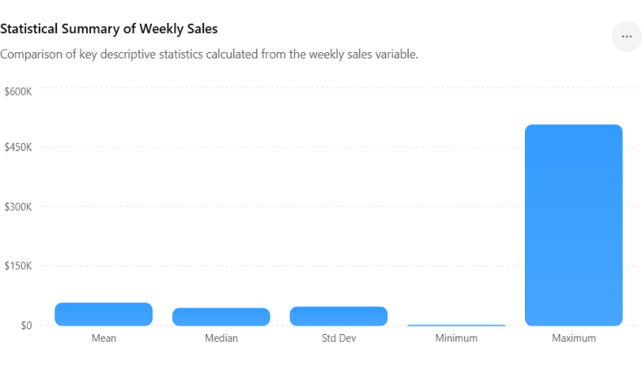
Interpretation
The chart summarizes the key descriptive statistics of weekly sales. The mean weekly sales value is $56,503.49, while the median is $43,394.87, indicating a positively skewed distribution caused by a relatively small number of high-sales observations. The standard deviation of $46,717.49 demonstrates substantial variability in sales performance. Furthermore, the large difference between the minimum sales value ($819.66) and the maximum sales value ($505,958.73) highlights significant disparities in weekly sales across stores and departments. These findings suggest that sales performance is influenced by multiple factors such as store location, department type, seasonal demand, and holiday periods.
3. Top Revenue-Contributing Store
Rank | Store ID | Total Revenue
1 | 32 | 303,223,000
2 | 41 | 301,811,900
3 | 5 | 300,063,900
4 | 1 | 299,905,000
5 | 11 | 292,354,000
6 | 37 | 291,374,300
7 | 6 | 290,117,900
8 | 47 | 285,766,700
9 | 38 | 280,749,400
10 | 23 | 279,639,000

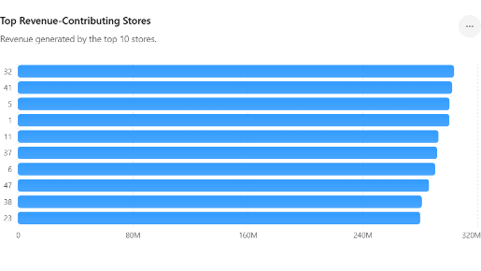

Interpretation: The store revenue bar chart illustrates the total revenue generated by the top-performing stores. Store 32 recorded the highest revenue contribution, closely followed by Stores 41, 5, and 1. The differences among the top stores are relatively small, suggesting a balanced revenue distribution among leading locations. These stores consistently achieved strong sales performance and significantly contributed to the organization's overall revenue. The chart helps identify high-performing stores that can serve as benchmarks for operational and marketing strategies.

4.Department Variability Analysis
Department | Mean Sales | Standard Deviation
20 | 75,936.35 | 60,334.59
19 | 73,401.92 | 57,421.49
18 | 71,819.05 | 56,492.67
17 | 69,205.18 | 55,319.08
16 | 67,908.46 | 53,568.80

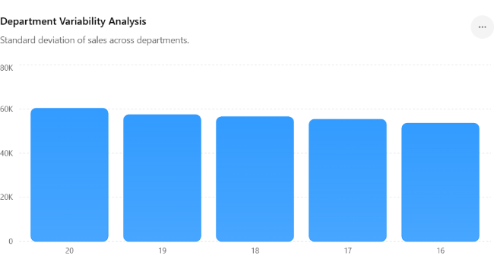
Interpretation: The department variability graph displays the standard deviation of sales for departments with the highest fluctuations. Department 20 exhibits the greatest variability, followed by Departments 19, 18, 17, and 16. High variability indicates that sales in these departments experience substantial changes over time, likely due to seasonal demand, promotional campaigns, or changing customer preferences. Departments with greater variability require more careful inventory planning and demand forecasting to avoid stock shortages or overstock situation.

5. Holiday Impact Analysis
Category | Average Weekly Sales | Total Sales
Holiday Weeks | 84,493.83 | 1.52 Billion
Non-Holiday Weeks | 52,852.58 | 7.29 Billion

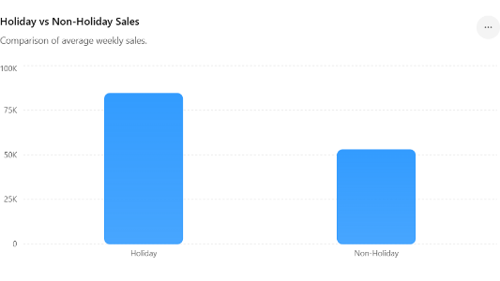
Interpretation: The holiday impact chart compares average weekly sales during holiday and non-holiday periods. The average sales during holiday weeks are significantly higher (₹84,493.83) than during non-holiday weeks (₹52,852.58). This substantial difference demonstrates the positive influence of holidays on consumer purchasing behaviour. Customers tend to spend more during festive seasons and special occasions, leading to increased sales volume. The findings suggest that retailers should strengthen promotional activities and inventory management during holiday periods to maximize revenue opportunities.
- Monthly Average Sales Analysis
Month | Average Weekly Sales
January | 59,409.68
February | 56,327.29
March | 49,096.70
April | 49,509.00
May | 48,642.59
June | 49,130.17
July | 51,878.72
August | 49,289.19
September | 62,113.26
October | 58,702.35
November | 73,301.88
December | 70,916.60

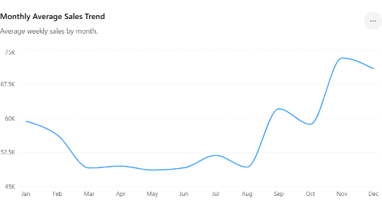
Interpretation: The monthly sales trend graph shows the variation in average weekly sales throughout the year. Sales remain relatively stable during the first half of the year, with a slight decline between March and August. A noticeable increase begins in September and continues through November and December. November records the highest average sales, followed closely by December. This trend reflects the impact of seasonal shopping, holiday celebrations, and year-end purchasing activities. The graph indicates strong seasonal patterns in customer demand, which can be leveraged for strategic planning and forecasting
- Top Store-Department Combinations
Rank | Store ID | Department | Total Revenue
1 | 5 | 20 | 21,949,526.84
2 | 32 | 19 | 21,348,232.29
3 | 1 | 20 | 20,751,644.53
4 | 41 | 20 | 20,744,989.41
5 | 32 | 20 | 20,494,554.56
6 | 37 | 20 | 20,176,748.92
7 | 32 | 18 | 19,877,295.48
8 | 41 | 19 | 19,803,142.88
9 | 23 | 20 | 19,797,188.71
10 | 5 | 18 | 19,721,355.87

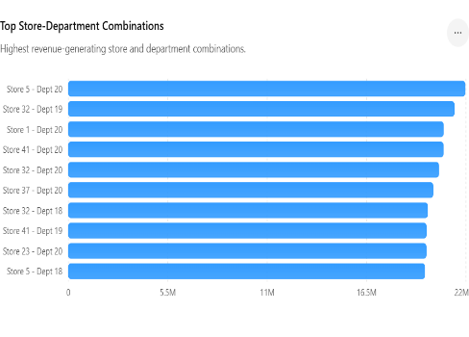

Interpretation: The store–department contribution graph highlights the combinations of stores and departments generating the highest revenue. Store 5–Department 20 achieved the highest contribution, followed by Store 32–Department 19 and Store 1–Department 20. The dominance of Department 20 among several top-performing combinations suggests that this department consistently generates strong sales across multiple stores. The analysis helps identify the most profitable store-department pairings and provides valuable insights for resource allocation, inventory optimization, and targeted marketing efforts.

Overall findings:
The graphical analysis reveals that sales performance is influenced by multiple factors, including store location, department characteristics, seasonal demand, and holiday periods. High-performing stores and departments contribute significantly to total revenue, while holiday seasons and year-end months generate substantial increases in sales. These insights provide a strong foundation for predictive modelling and strategic business decision-making in the subsequent stages of the analysis.

Conclusion
The objective of this project was to analyse retail sales data and develop a machine learning-based approach for understanding sales patterns and predicting future sales performance. Through exploratory data analysis and statistical evaluation, several important insights were obtained regarding the factors influencing weekly sales across stores and departments.
The analysis revealed that weekly sales exhibit considerable variation across different stores and departments. The statistical summary showed an average weekly sales value of ₹56,503.49, with a high standard deviation of ₹46,717.49, indicating substantial fluctuations in sales performance. The large difference between the minimum and maximum sales values further confirms the presence of significant variability within the dataset.
Store-level analysis identified Store 32 as the highest revenue-contributing store, followed closely by Stores 41, 5, and 1. This finding indicates that certain stores consistently outperform others and contribute significantly to overall business revenue. Department-wise analysis showed that Department 20 generated the highest variability in sales, suggesting stronger customer demand fluctuations and greater sensitivity to seasonal or promotional factors.
The comparison between holiday and non-holiday sales demonstrated that holiday periods have a substantial positive impact on revenue generation. Average weekly sales during holiday weeks were considerably higher than during non-holiday weeks, highlighting the importance of seasonal events and festive shopping behaviour in driving retail sales.
Monthly sales trend analysis revealed a clear seasonal pattern. Sales remained relatively stable during the first half of the year but increased significantly from September onwards, reaching their highest levels during November and December. This pattern suggests that customer purchasing activity intensifies during festive and year-end periods, making these months particularly important for retail planning and inventory management.
The store-department contribution analysis further showed that combinations involving Department 20 consistently generated the highest revenues across multiple stores. This indicates that certain product categories play a major role in overall sales performance and deserve greater strategic attention.
The machine learning component of the project demonstrated the applicability of predictive analytics in retail sales forecasting. By utilizing historical sales data and relevant features, predictive models can assist businesses in estimating future demand, optimizing inventory levels, and improving operational decision-making.
In conclusion, the project successfully achieved its objective of analysing retail sales behaviour and identifying key factors affecting sales performance. The findings provide valuable business insights and demonstrate how data analytics and machine learning can support strategic decision-making, improve forecasting accuracy, and enhance overall retail management efficiency.
.

APPENDICES
References: -
- SAS Retail Analytics- https://www.sas.com/en_in/industry/retail.html?
- Skit-Learn Documentation - https://scikit-learn.org/stable/index.html
- Scikit-Learn – F1 Score Documentation - https://scikit-learn.org/stable/modules/generated/sklearn.metrics.f1_score.html?
- GeeksforGeeks – K-Means Clustering Introduction - https://www.geeksforgeeks.org/machine-learning/k-means-clustering-introduction/

Github link: -
- https://github.com/Rajanya28/14-Exploratory_data_analysis_with_sales_data_Summer_2026.ipynb/blob/main/14_Exploratory_data_analysis_with_sales_data_Summer_2026.ipynb

Add report to github
- Data analytics - https://www.ibm.com/think/topics
- SAS Retail Analytics- https://www.sas.com/en_in/industry/retail.html?
- Skit-Learn Documentation - https://scikit-learn.org/stable/index.html
- Scikit-Learn– F1 Score Documentation - https://scikit-learn.org/stable/modules/generated/sklearn.metrics.f1_score.html?
- GeeksforGeeks –K-Means Clustering Introduction - https://www.geeksforgeeks.org/machine-learning/k-means-clustering-introduction/

Github link: -
- https://github.com/Rajanya28/14-Exploratory_data_analysis_with_sales_data_Summer_2026.ipynb/blob/main/14_Exploratory_data_analysis_with_sales_data_Summer_2026.ipynb
- Report link

